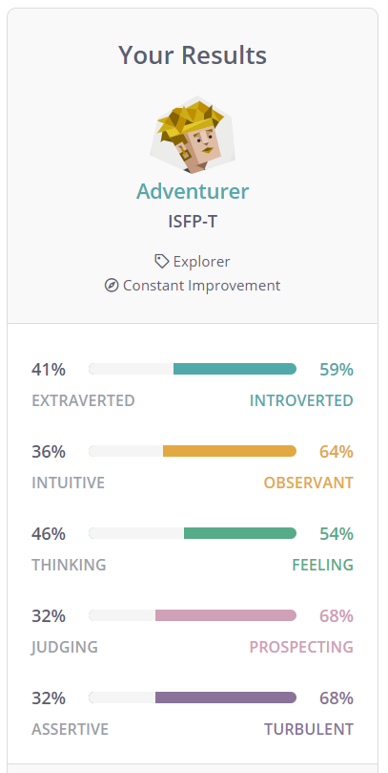

1. What do the results of these tests mean for you?

This quiz doesn’t give me much to work on, normally other quizzes would have a breakdown of what the percentages mean. This only gives me a brief overview of the overall picture regarding my personality. The categorization sets me as an Adventurer, but does not break down what an Adventurer means.

1. How do you think these results may influence your behaviour in a team?

In this scenario I don’t think it will influence me a lot as I do not understand the results very much. It will overall most likely distract me whilst working in teams and make me doubt my actions as I don’t know what the results actually mean.

1. How should you take this into account when forming a team?

I don’t think this will affect me when forming teams, but it will affect my performance as it will constantly distract me as mentioned before.